We are collecting Box Tops to earn money for our school. The class that brings the most will earn an extra P.E. class!

**Please ask your child about this…**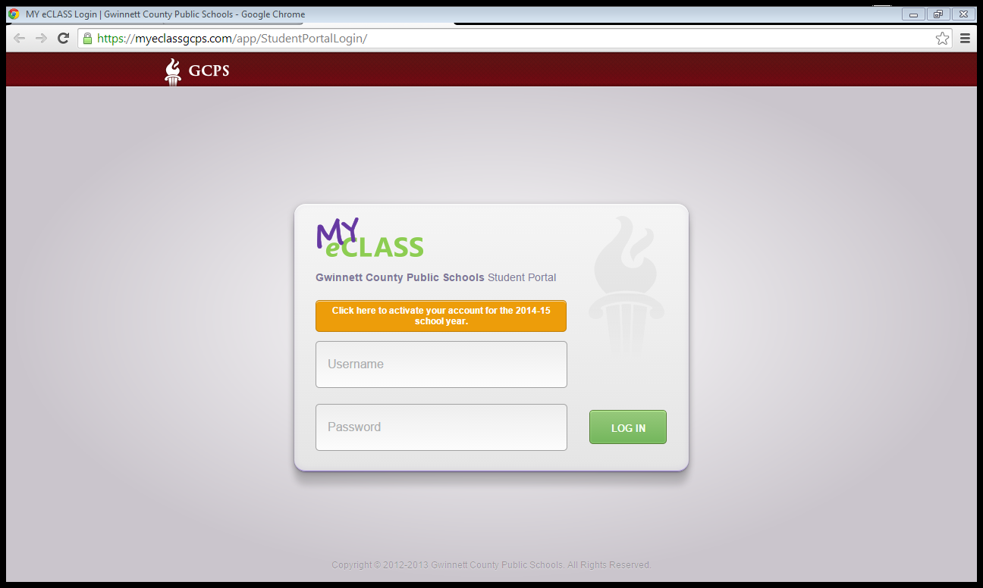

**Do they know how to login? Do they remember their password? This will soon take the place of my website.**

[**www.myeclassgcps.com**](http://www.myeclassgcps.com)

*We are studying…*

*Language Arts:*

We will complete our Jonathan London author study. We are working on discovering the author’s purpose for various types of books. We are also making inferences and finding text evidence in stories.

Writing- We will be reading about penguins this week and writing two different types of stories- informational and opinion. We will practice spelling -op and -ob words.

Math: We will be discovering ways to make ten and learn how this can be helpful in math.

Science: We will continue our unit on light and shadows.



We have begun the Accelerated Reader program with first graders. This program is voluntary. It allows students to read certain books and take tests on the computer. They can set goals, earn prizes, and even earn a visit to a magic show. Please let me know if you have any questions.

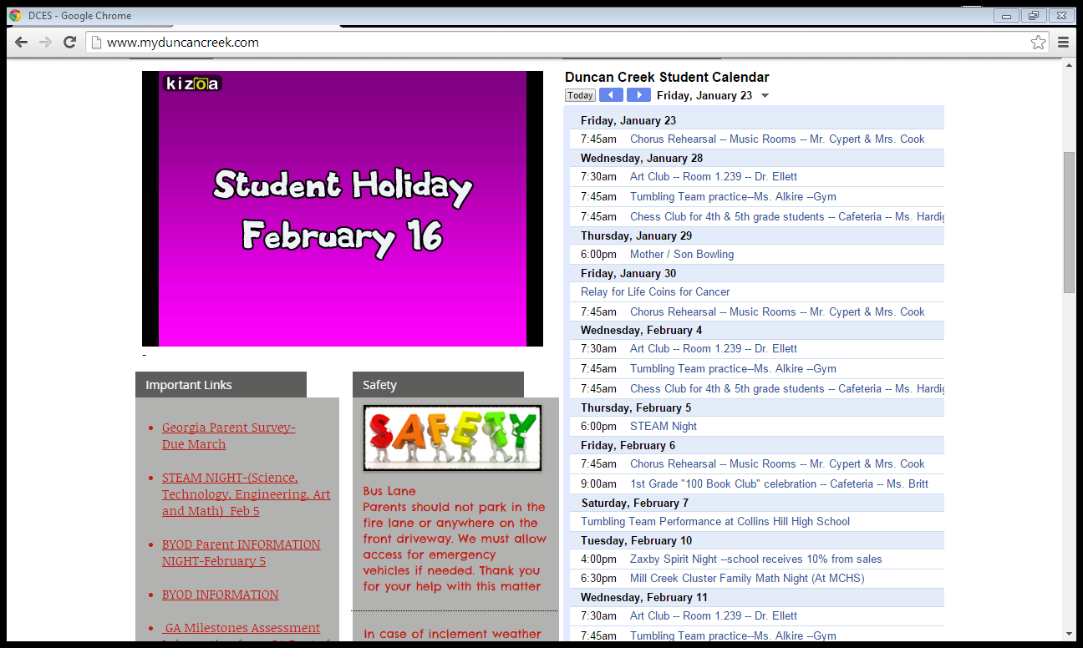

**Specials for the week of January 26:**

Monday: S.T.E.M.

Tuesday: P.E. *Wear sneakers.

Wednesday: Art

Thursday: Music

Friday: S.T.E.M.

Remember to check our class website: [www.cindybaker.weebly.com](http://www.cindybaker.weebly.com)